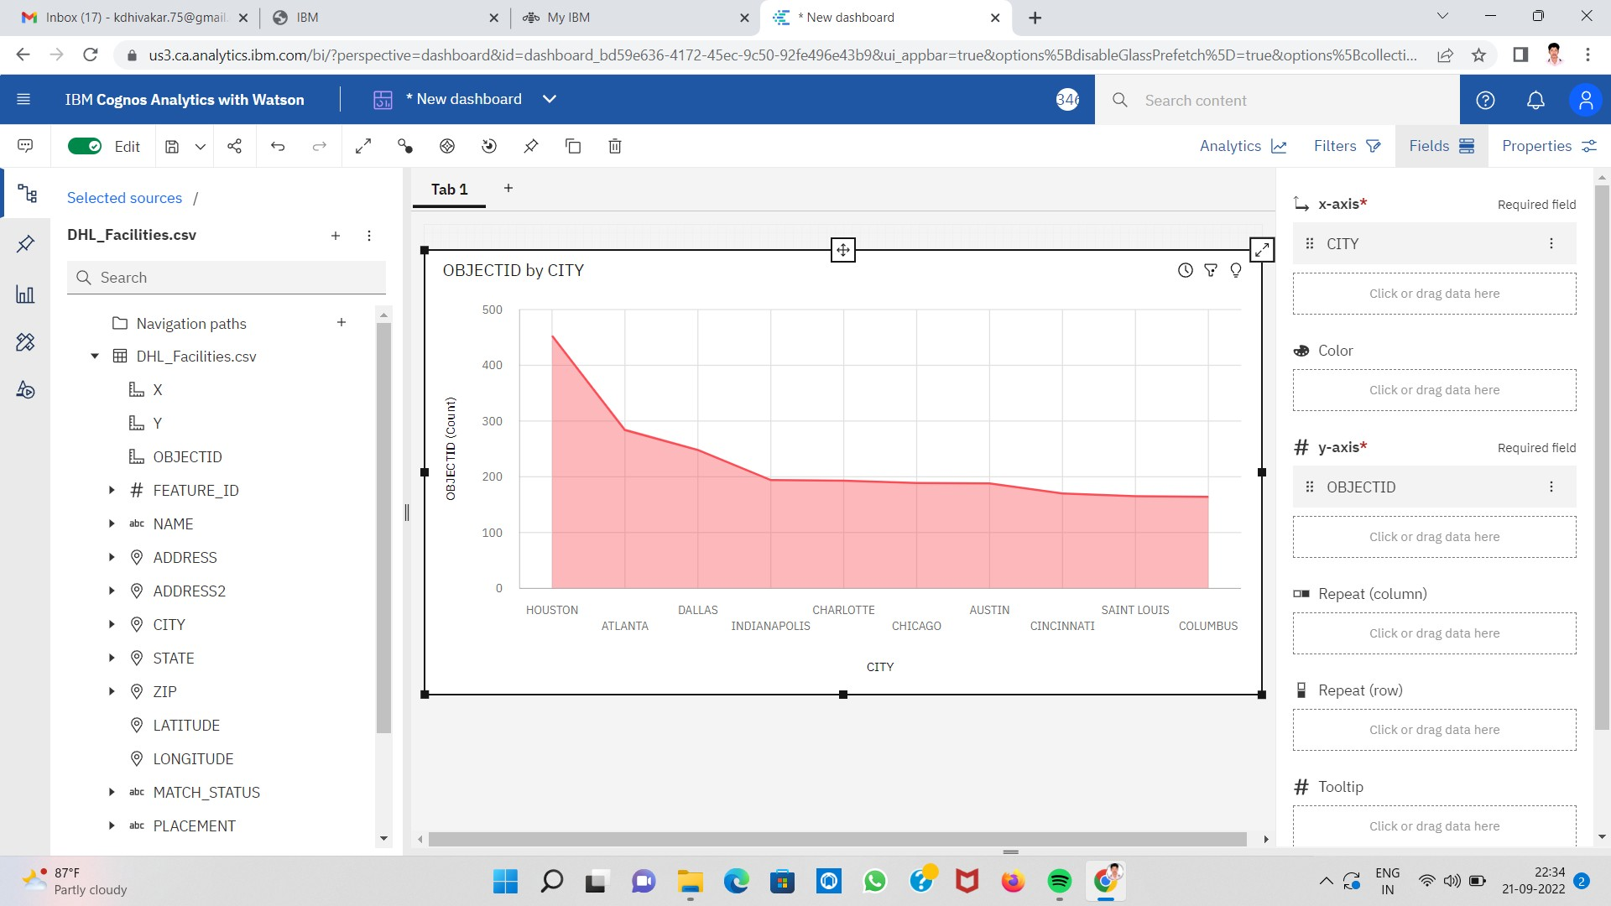

Area Chart Showing City Wise DHL Deliveries